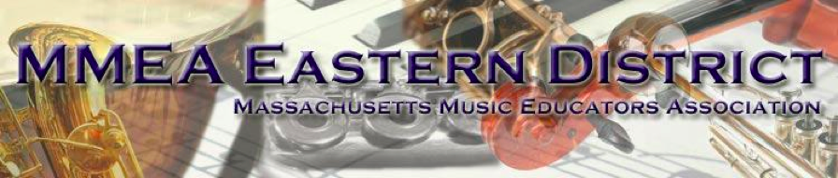
SENIOR FESTIVAL - OFFICIAL AUDITION LIST FALL 2017

Instrument/Voice | Title
Voice | DiLasso - I Know a Young Maiden, ECS PUBLISHING 1606
Violin | Mozart - Concerto #3 in G, 1st Mvt., No Cadenza - G. Schirmer (Franko) 50260250
Viola | Handel/Casadesus - Concerto in B minor, 1 st Mvmt., Suzuki Book 7, Alfred 0493
Cello | Vivaldi - Sonata #3 in a, 1st & 2nd Mvts. - INT 1374
String Bass | Bach/Sterling – First Suite, Gigue, Suites for Cello Vol. 1 - Peters 238B
Harp | CPE Bach/Miller - Solfeggietto, Carl Fischer, H23
Flute | Muczynski - Three Preludes, Op. 18, G. Schirmer 50290620
Oboe | Schumann- Romance No.2, Oboe Solos, ed. Arnold, 14023895
Bb Clarinet | Pierne/Voxman - Canzonetta , Concert and Contest Collection, Hal Leonard 04471630
Bass Clarinet | Galliard - Sonata #2 of the Six Sonatas Vol. 1, p.4 and 5, McGinnis & Marx 2825
Bassoon | Weissenborn - Method #15 Carl Fischer CU96)
Alto Saxophone | Jacobi - Sonata for Alto Sax, Mvts 1 & 2, pub. Bourne 121009
Tenor Saxophone | Bach/Caravan - Cello Suite #2 Mvt. 1, (Pgs. 46-47), Bach for the Saxophone, pub. Ethos
Baritone Saxophone | Caravan - Sonata Mvt. 1 & 2 (no cadenza), pub. Ethos (jwpepper number 5007737)
Trumpet | Ropartz - Andante and Allegro Carl Fischer ed. (CU572)
French Horn | Strauss - Concerto No.1 in Eb Major, 1st mvmt, International 1715
Trombone | Koepke - Prelude and Fanfaronade, Concert & Contest Collection, Hal Leonard 04471790
Bass Trombone | Mccarty - Sonata, Mvmt 3, Ensemble Pub., ENS014
Euphonium (BC/TC) | Haydn - Divertimento, Classic Festival Solos Vol. 2, Alfred EL03893
Tuba | Walters - Concertante, Rubank, Hal Leonard 04479318
Snare Drum | Cirone - Portraits in Rhythm No.5, Alfred HAB00101
Timpani | Whaley – Musical Studies for the Intermediate Timpanist, , p.25, JR Pub. 54
Mallets | Bach/Whaley - Bouree from Partita No. 1, Recital Pieces for Mallets, JR Pub. 52
Auxiliary Percussion | All Percussion Auditions (including snare, mallets and timpani):  Tanner - Solo No. 8, Eight(+4) 3-minute Audition Solos for Multiple Percussion, Mostly Marimba S4M

Jazz Requirements
Jazz Auditions: | Snidero – Joe’s Thing, Jazz Conception, Advance Music. Students will be asked to perform solo with recording (minus soloist with rhythm section only). Drummers be sure to prepare the transcription, not the lead sheet.
Jazz Improvisation: | Students will be asked to improvise over changes in Joe’s Thing
Guitar/bass/piano/vibes: | In addition to the written solo, students will comp changes from assigned solo. Be prepared to comp a standard blues progression and a ii V I progression in keys up to and including 4 sharps and 4 flats.
Jazz Drums: | In addition to the listed performance solo, drummers should prepare to play in a funk style, a swing style, and a bossa nova style. These styles should be demonstrated in the format of four bars of time followed immediately by a four bar solo. These pieces should demonstrate technical and musical control of the drum set.

